TASK | COSHH Assessment
LOCATION OF USE | Workshop |  | Assessment  No |  | 022
PRODUCT NAME | Dry Moly Spray
DESCRIPTION OF SUBSTANCE | Aerosol lubricant which protects at high temperatures and high load pressures. (Dark Grey)
MANUFACTURER | Solent Lubricants
MANUFACTURERS CONTACT | Solent, Wigston, Leicester, L18 2FS  Tel: 0116 288 8000 Fax: 0116 288 8222  Emergency Telephone Number: 01942 713667
ASSESSOR | Martin Monaghan CMIOSH |  | Date |  | 04 12 25
TITLE | Health and Safety Consultant |  | Review by |  | 04 12 27
Personnel Performing Task:  Technicians/ Fitters/ Workshop Operatives |  | Time Spent  (Minutes/day)  As and when required, amounting to a few minutes per day | Training Given 
 |  |  | Yes

MSDS Revision Date | Risk Phrases/Hazard Statements
May 2015 | H220-Extremely Flammable gas  H222- Extremely Flammable Aerosol  H226-Flammable liquid and vapour  H229- Pressurised container; May burst if heated  H280-Contains gas under pressure may explode if heated  H304-May be fatal if swallowed and enters airways  H319- Causes serious eye irritation  H336- May cause drowsiness or dizziness  H412- Harmful to aquatic life with lasting effects

Assessment to be conducted in association with Safety Data Sheets, a full current copy of which must be attached to this assessment.

Please denote the hazardous properties of the substances used in the task with a 

NEW INTERNATIONAL GLOBALLY HARMONISED HAZARD SYMBOLS (labelling information)
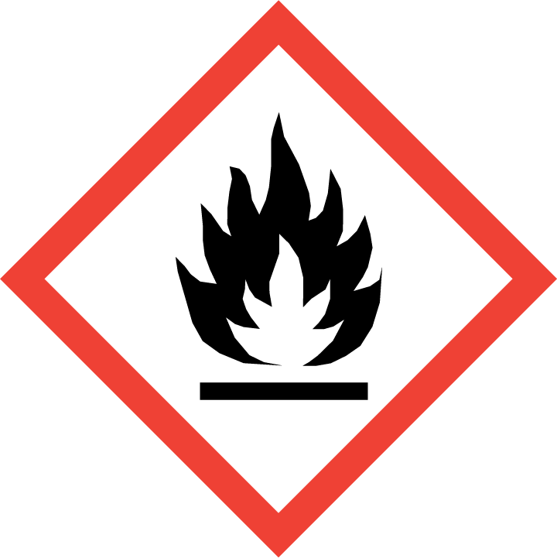 | 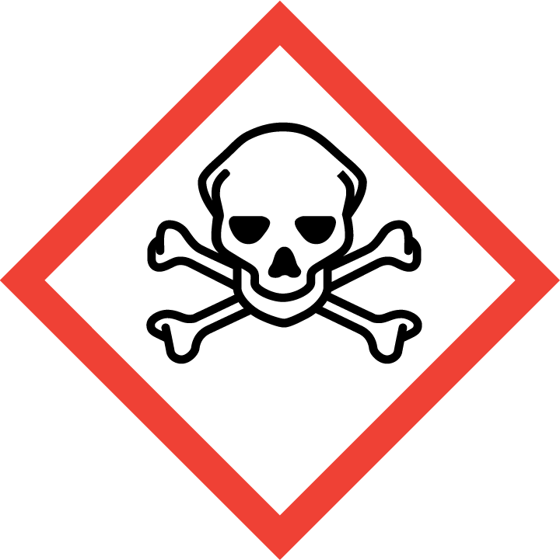 | 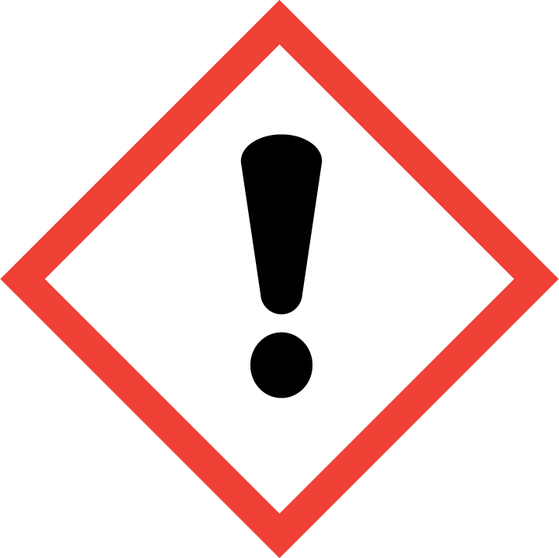 | 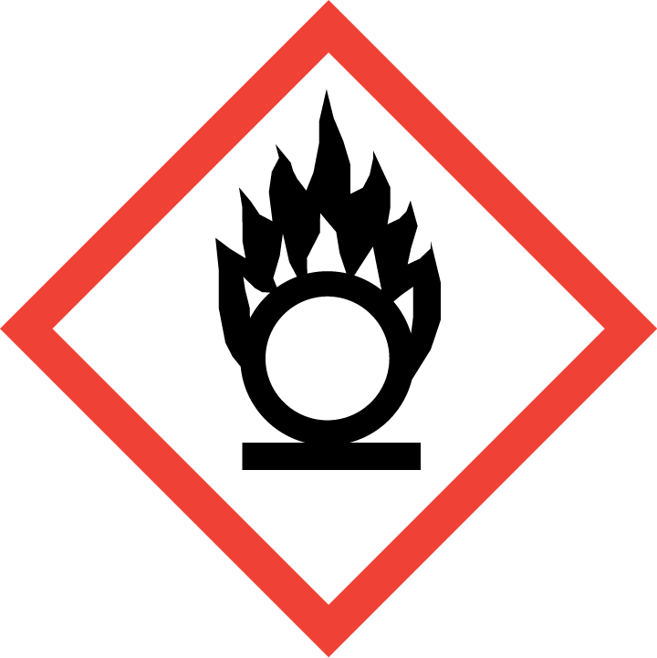 | 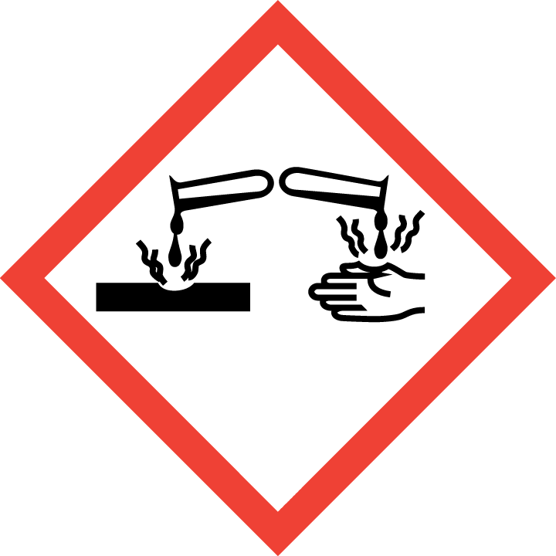 | 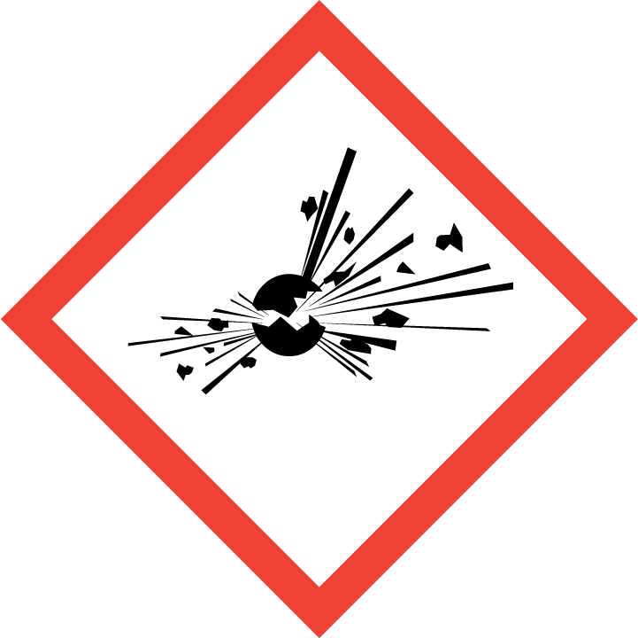 | 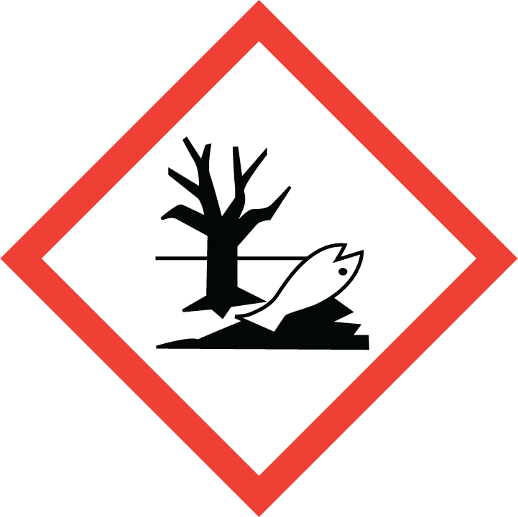 | 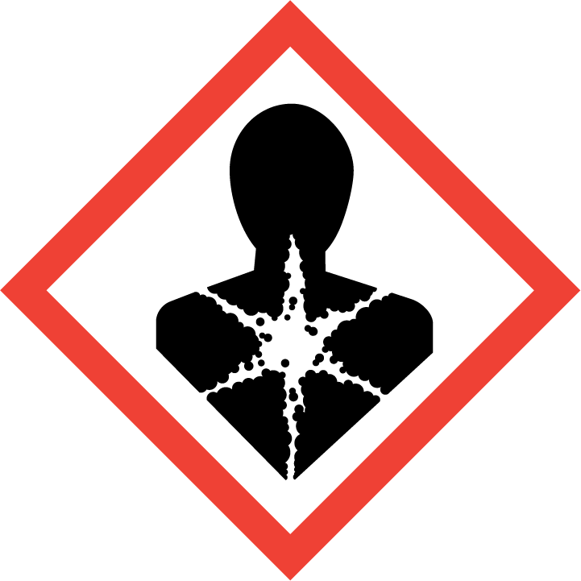
Flammable  Extremely | Toxic | Harmful  Mild irritation on the eye | Oxidising | Corrosive | Explosive | Harmful to the environment | Health Hazards i.e. respiratory sensitisation or carcinogenicity
 |  | 

SMOKING, EATING AND DRINKING ARE PROHIBITED IN THE WORK AREAS.
Information, Instruction and Training must be provided to all users. Young Persons, New or Expectant Mothers and other vulnerable groups must not use or be exposed to this product.

WORKPLACE EXPOSURE LIMITS (WEL’s)
Note: Workplace Exposure Limits are Occupational Exposure Limits set under COSHH Regulations 2004. Harmful substances and their WELs are listed in a publication called EH40 Workplace Exposure Limits.

Ingredients with limit values that require monitoring at the workplace:

115-1016 dimethyl ether Short-term value: 958mg/m³, 500ppm
WEL Long-term value 766mg/m³, 400ppm

67-64-1 propan-2-one Short-term value: 3620mg/m³, 1500ppm
WEL Long-term value 1210mg/m³, 500ppm

1330-20-7 Xylene (mix) Short-term value: 441mg/m³, 100ppm
WEL Long-term value 220mg/m³, 50ppm

Exposure monitoring must be undertaken to determine accurate worker exposures.

Ingredients with biological limit values:

1330-20-7 Xylene (mix) BMGV 650 mmol/mol creatinine
Medium:urine
Sampling time: post shift
Parameter: methyl hippuric acid

IMPORTANT!
Refer to Workplace Exposure Levels information provided in the Manufacturer’s Safety Data Sheet and revise control measures if exposure levels likely to be reached.

ROUTE OF EXPOSURE
Skin |  | Eyes |  | Inhalation | 
Ingestion |  | Cuts/abrasions |  | Systemic | 

PERSONS AT RISK
User of product |  | Co workers |  | Members of the public

ROUTE OF EXPOSURE |   FIRST AID MEASURES
Eyes | Hold eye open and rinse slowly and gently with water for 15- 20 minutes. Obtain medical attention
Skin | Wash skin immediately with soap and water. Remove any contaminated clothing. Do not keep contaminated cloths or rags in overall pockets next to the skin.
Inhalation | Remove person to fresh air and keep comfortable for breathing. Call a doctor if you feel unwell.
Ingestion | Unlikely route of exposure. Wash out mouth with water. Do not induce vomiting. Risk of aspiration
In all cases of doubt, or if symptoms persist seek medical attention. Never give anything by mouth to an unconscious person. If unconscious, place in recovery position and seek medical advice.

PERSONAL PROTECTIVE EQUIPMENT
 |  |  Face mask/ Dust mask | 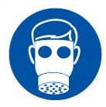 Respirator |  |  Face Shield
 |  |  |  | 
Tightly sealed goggles | Suitable long-sleeved coveralls. |  | In case of insufficient ventilation, wear suitable respiratory equipment. A suitable mask with filter type A (EN14387 or EN405) may be appropriate. | Blue nitrile rubber gloves or equivalent recommended.

HANDLING | STORAGE | TRANSPORT | DISPOSAL
Keep away from heat, hot surfaces, sparks, open flames and other ignition sources. No smoking. Keep away from: Electrostatic charge. Do not spray on an open flame or other ignition source. Do not pierce or burn, even after use. Do not let the can touch battery terminals, electrical connectors or any source of electricity. Use product in a well-ventilated area only. Ensure adequate ventilation. Avoid breathing vapours. Avoid prolonged skin contact. Wear protective gloves. | Protect from sunlight. Store in a well-ventilated place. Industrial product for professional use. Locked storage does not apply to this product. Storage Temperature Do not expose to temperatures exceeding 50°C/ 122°F. Storage Life Stable under normal conditions | Keep aerosols upright, do not mix with other chemicals. Incompatible materials:  Oxidizing agents, Reducing agent. | Must not be disposed together with household garbage. Do not allow product to reach sewage system. Disposal must be made according to official regulations.

GENERAL CONTROL MEASURES
- Users to avoid contact with skin and eyes, and inhalation of vapours/ spray or mist arising from the application of this preparation – Use PPE.
- Only opened solvent containers should be kept at the bench.
- When not in use, opened solvent containers should be kept in the flammables cupboards, under the work benches.
- Surplus/ un-opened solvents must be kept in stores/ parts department.
- Ensure adequate welfare and washing facilities available and provide users with barrier and restorative creams.
- Ensure operatives are made aware of and understand the purpose of this assessment and SDS, plus any health implications of using the product.
- Ensure COSHH assessments with accompanying SDS are made available for all employees and users and for inspection and emergency purpose.
- Carry out personal exposure monitoring.

FIRE PRECAUTIONS
Suitable Fire Extinguishing Methods:
CO2, powder or water spray. Fight fires with water spray or alcohol resistant foam

Special hazards arising from the substance or mixture
Heating may cause pressure rise with risk of bursting.

Advice for fire-fighters
Fire fighters should wear complete protective clothing including self-contained breathing apparatus. If it is safe to do so, containers should be removed from fire area because they are likely to rupture under fire conditions. Keep fire exposed containers cool by spraying with water.

ACCIDENTAL RELEASE/SPILLAGE PROCEDURES
The product is an aerosol. It is unlikely to present spillage or leakage hazard. In case of rupture, released content should be contained as any other solvent spill.

Personal precautions, protective equipment and emergency procedures
Wear protective equipment. Keep unprotected persons away.

Environmental precautions
Do not allow to enter drains, sewers or watercourses. Spillages or uncontrolled discharges into watercourses must be alerted to the appropriate regulatory body.

Methods and material for containment and cleaning up Place leaking cans in a bucket or pail to minimise product contamination of surfaces. Collect spillage. Absorb remaining liquid in sand or inert absorbent and remove to safe place. Transfer to a container for disposal. Do NOT wash away into sewer. Containers must not be punctured or destroyed by burning, even when empty.

MONITORING REQUIREMENTS AND HEALTH SURVEILLANCE
No health surveillance in place at present.

